Actions for this week:
Choose a research topic; review my previous work; and search for high-quality UK master’s dissertations and journal/conference papers in related areas.

What did I do this week? Why did I do this?
By summarising the coursework from the past two semesters, as well as the text-satire detection research proposal I wrote last semester for the *Individual Research Project Preparation* module, I ultimately chose a more familiar topic—human activity recognition—as my research project. After deciding on the topic, I began to review the details of the human activity recognition work I had done last semester, such as the preprocessing pipeline, models, datasets, and so on. At the same time, I also looked up high-quality UK master’s dissertations and journal/conference papers in related areas to serve as references for the later stages of my research.

Preparing the research direction early gives me more ample and well-planned time. I cannot predict what difficulties I may encounter later in the project, and some challenges might halt my progress for quite a long period. In addition, because I have not engaged with this material for some time, I have partially forgotten it and feel somewhat rusty. Although I already worked on this topic last semester, there are still many details that I do not fully understand.

In some cases, picking up previous work again after a break can lead to unexpected gains, because during the rest period the brain continues to integrate and reorganise knowledge. This is another reason why it is necessary to start the project early: studying for one hour a day over ten consecutive days is more effective than studying for ten hours in a single day.

Outcomes and findings:
In computer science, especially in data science and artificial intelligence, there are many possible research directions I could choose from. I realised that choosing an appropriate topic is a very important problem—sometimes it may even be more important than the project itself. If I pick the wrong topic and only realise halfway through that it is difficult to continue, that would be a very tricky situation.

Reflection:
Choosing a research topic requires careful consideration, taking multiple factors into account. For example:

* How many gaps currently exist in this area, and how much room is there for genuine innovation?
* Is the field mature enough, with sufficient community support and easily accessible tools to reproduce previous work?
* What platforms and environments are required for this project, is it feasible to complete everything with just a laptop?
* Are the existing gaps in this field realistically addressable by a master’s student working alone, under constraints of time, resources and energy?

Have I finished this week’s action? What percentage? If not, how to improve?
Completion rate: 100%.

Actions for next week:
Gain a deeper understanding of my chosen research topic.

Detailed thought process:

Choosing a research topic
I remember that in the first semester, Professor Omid said in a lecture, “It’s a very good idea to start thinking early about what you want to do for your third-semester individual research project.” He also mentioned, “The individual research project is not asking you to design something revolutionary like ChatGPT. Your topic needs to be manageable and under control.”

Then a classmate asked, “Can I collect my own dataset?” Professor Omid replied, “You can, but collecting your own dataset will cause a lot of trouble. First, there is the time cost of collecting it. Then, how will you ensure that the dataset you collect is fair and objective? Finally, you also have to think about the ethics application.”

Based on this experience, I decided to start my project now, during the study break.

The first idea that came to mind was the research plan I wrote in the Individual Research Project Preparation (IRP Preparation) assignment in the second semester, where my original topic was using large models for linguistic sarcasm detection. However, after a deeper investigation, I realised that this kind of work usually requires a lot of time and high-end hardware; training large models is both time-consuming and quite risky.

Last semester I studied machine learning, and the lecturer recommended some human activity recognition (HAR) datasets. After looking into them more carefully, I found that HAR research often focuses on lightweight models, and the risks are more controllable. I also came across a WeChat mini-program called “Daily Step Count,” which has a friends leaderboard feature. I think this kind of idea is both interesting and promising.

In the Individual Research Project Preparation module in the second semester, Dr Peter emphasised, “The field you choose needs to be sufficiently challenging. You should identify a gap, then conduct research and make a contribution.” So I began to explore the HAR field and found that there are still many gaps. Although large-model sarcasm detection might push the frontier further, it does not seem suitable for a three-month master’s project. In contrast, human activity recognition allows me to use many high-quality public datasets.

Therefore, I finally decided to choose human activity recognition as my research topic.

Once the topic was decided, the next step was to become familiar with it and understand the field. When I thought about how to do this, three approaches came to mind, roughly ordered from most to least difficult:

1. Reading conference/journal papers in the area, especially authoritative, core venues.
2. Reading master’s dissertations from other UK universities in related fields.
3. Looking at sample assignments from previous students provided by my supervisors.

Considering that the individual research project is not like a normal coursework assignment and that students may use very different research methods, I ruled out method 3. Method 2 seems quite good, because the format and content of UK master’s dissertations should not differ too much between universities. Method 1 is useful for getting in touch with the research frontier, but after some investigation, I realised that simply turning a top-tier conference/journal paper into a UK master’s dissertation would not necessarily receive a high mark, because the requirements and expectations for the two are not the same. So I decided to start with method 2.

Although I am still in the study break and do not yet know the exact requirements for the third-semester project, I assume the dissertation will probably be around 12,000 to 15,000 words. This is far longer than any single assignment in one semester, and roughly equivalent to the total word count of four modules combined. Therefore, I think it is necessary to dig deeply into the research area, rather than staying at the shallow level of previous coursework.

After checking, I found that Coventry University does not publicly provide strong master’s dissertations in the HAR field, so I chose to study good dissertations from other UK universities in related areas.

Links:
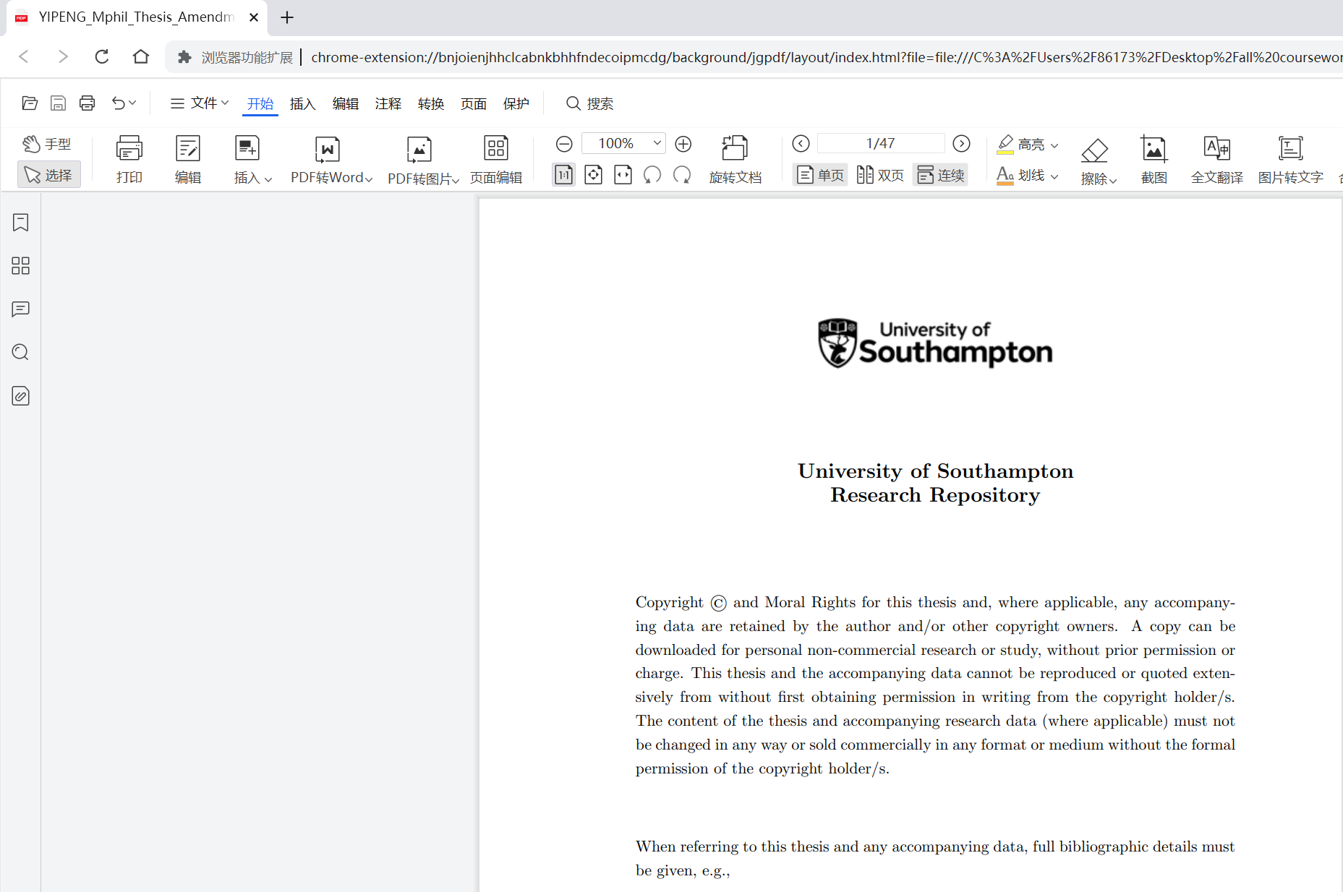


Enokibori, Y. (2024). rTsfNet: A DNN model with multi-head 3D rotation and time series feature extraction for IMU-based human activity recognition. Proceedings of the ACM on Interactive, Mobile, Wearable and Ubiquitous Technologies, 8(4), Article 202. https://doi.org/10.1145/3699733

Huang, W., Zhang, L., Wu, H., Min, F., & Song, A. (2023). Channel-equalization-HAR: A light-weight convolutional neural network for wearable sensor based human activity recognition. IEEE Transactions on Mobile Computing, 22(9), 5064–5077. https://doi.org/10.1109/TMC.2022.3174816

